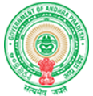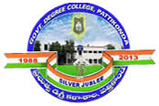**Government Degree College**

**ACCREDITED BY NAAC WITH ‘B’ GRADE** **Pattikonda,Kurnool (Dt),A.P.518380.**

**Dr R.Madhuri,**

**Principal ,**

**4.1.1 - The Institution has adequate infrastructure and physical facilities for teaching- learning. viz., classrooms, laboratories, computing equipment etc.**

**The college has a campus area of 6.5 hectares. The college has three buildings: Arts, commerce and science blocks. The college has well experienced Faculty of Arts, Science & Commerce. The college has excellent infrastructure facilities to carry out these programs Classroom equipment – The classroom has a great importance to the overall development of students in social, educational and cultural, which contributes to the development of responsible citizens of the country.**

**We aim at the holistic development of our students. Our college classrooms provide students with a comfortable environment for learning and general self-development through variety of activities. The Details of Laboratories- College has 08 laboratories under all the faculties. All the Laboratories are well equipped and having good number of instruments to give hands on experience to all the undergraduate students. All the Laboratories are designed as per the need of the subject and to make the working more effective. Language lab is equipped with all the required software’s and audio visual aid. Seminar hall- A dedicated seminar hall with audio-visual facilities is in place for regular use. Computer Laboratories are having good facilities to avoid exposure of computing facilities to dust and thermal runaway of hardware.**