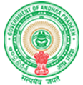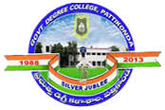**Government Degree College**

**ACCREDITED BY NAAC WITH ‘B’ GRADE** **Pattikonda,Kurnool (Dt),A.P.518380.**

**Dr R.Madhuri**

**Principal**

**5.4.1 - Alumni Engagement 5.4.1 - There is a registered Alumni Association that contributes significantly to the development of the institution through financial and/or other support services.**

**The college has produced many graduates since its founding, many of whom are located abroad and actively serving their country. According to the regulations of the Government of A.P. this college has been given permission to have an exclusive organization called the ALUMNI Association, which is made up of former students who are businesspeople, academicians. The alumni body is empowered to mobilize resources and use them for the development of the institution. The alumni association is primarily formed to support academic, administrative, infrastructural, and co-curricular activities in the institution with those who are interested in giving back.**

**Meetings of the alumni association are held, and they actively participate in growth endeavors. They offer insightful feedback on a range of topics pertaining to extracurricular, curricular, and disciplinary activities. In other words, alumni help the college write its history. The institution provides students with a welcoming setting and a quality educational environment with the goal of fostering their intellectual and personal development. The Association's purpose and goals are**

**1. To keep track of every former college student.**

**2. To encourage and cultivate friendship among current and former college students.**

**3. To offer a platform for discussion on social and scholarly issues.**

