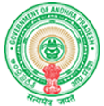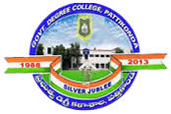**Government Degree College**

**ACCREDITED BY NAAC WITH ‘B’ GRADE** **Pattikonda,Kurnool (Dt),A.P.518380.**

**Dr.M.Purshotham Reddy,**

**Principal,**

**Describe at least two institutional best practices**

**08.03.2018-Blood Donation Program**

**04.01.2019-Personality Development Program**