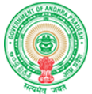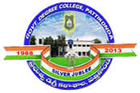**Government Degree College**

**ACCREDITED BY NAAC WITH ‘B’ GRADE** **Pattikonda,Kurnool (Dt),A.P.518380.**

**Dr R Madhuri,**

**Principal ,**

