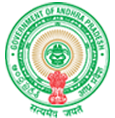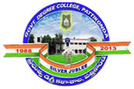**Government Degree College**

**ACCREDITED BY NAAC WITH ‘B’ GRADE** **Pattikonda,Kurnool (Dt),A.P.518380.**

**Dr.M.Purshotham Reddy,**

**Principal,**

**Provide the details of the performance of the institution in one area distinctive to its vision, priority and thrust in not more than 500 words**

**Hosur Village was adopted by NSS Units of Government Degree College, Pattikonda. from 02-1-2019 to 11-1-2019 volunteers conducted social survey and clean and green program, in the village. volunteers also distributed pamphlets against alcohol addiction and child marriages.**