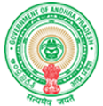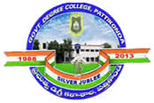**Government Degree College**

**ACCREDITED BY NAAC WITH ‘B’ GRADE** **Pattikonda,Kurnool (Dt),A.P.518380.**

**Dr.M.Purshotham Reddy,**

**Principal,**

**Describe at least two institutional best practices**

**1. Fruits distribution to the old age home.**

**2. Books Distribution to the poor students.**

**3. Study Material disturbed to Disabled school students**

**4. Awareness on Alcohol Addiction in slum areas.**

**5. Distributed bred & old clothes to the homeless.**