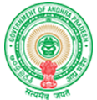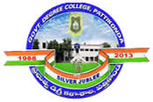 **Government Degree College**

**ACCREDITED BY NAAC WITH ‘B’ GRADE**

**Pattikonda,Kurnool (Dt),A.P.518380.**

**TEACHING-LEARNING AND EVALUATION-II (AY: 2022-23)**

Every student has different cognitive ability. Same method of teaching and pace is not suitable to everyone. The students are from different socioeconomic- cultural back grounds and their ability and comprehension is unique. Their ability to understand, analyze and evaluate their domain knowledge varies and is different.

**(Assessment of learning levels of the students)**

Advanced learners, mediocre learners and slow learners are identified on the basis of Performance in intermediate Examinations, internal assessment, university end examination, involvement in classroom.

**(Advanced learners)**

Guest Lectures are arranged for advanced learners along with the remaining students so as to gain additional knowledge regarding the respective discipline. Additional inputs are being provided to the advanced learners besides the curriculum. Encouraged to participate in group discussions, technical quiz to develop analytical and problem-solving abilities through they enhance their presentation skills.

**(Slow learners)**

During the course of study, group of students are assigned to a faculty for counseling/Mentoring. Mentors monitor academic performance and interact regularly to understand and help any student facing issues that affect their ability to learn or hinder their academic success.

