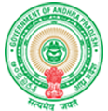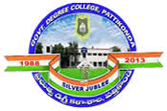**Government Degree College**

**ACCREDITED BY NAAC WITH ‘B’ GRADE**

**Pattikonda,Kurnool (Dt),A.P.518380.**

**2.3.2 Teachers use ICT enabled tools for effective teaching-learning process.**

**Faculty members were trained by an online one week FDP programs on “LMS Video & Pedagogy : Imaging and shaping of Digital Education & LMS towards development of High- Quality content” where training on Video making, APP based end to end editing tools, open educational resources, OBS studio and pedagogy and assessment had been conducted. Subject wise FDPs also were conducted by Commissionerate of collegiate education, Govt of Andhra Pradesh (CCE) for all faculty members on recent trends, progression in pedagogy in their subjects. An institutional level workshop is also conducted to all the faculty members on the usage of ICT tools.**

**Further college subscribed a G-Suite domain and all the faculty member are provided logins and Laptops. During the pandemic all teaching learning process conducted through online mode only using G-Suite, Teachmint, CISCO Webx and Zoom apps etc. All the class work along with the recorded video links were uploaded in the Bharatpade online and OTLP (Online Teaching Learning Process) app Managed by CCE, Govt of AP. All the communication related to class work, assignments, Examinations and academic related issues during online training was happened through the class whatsapp groups.**

