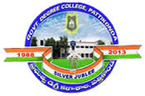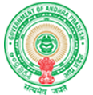**Government Degree College**

**ACCREDITED BY NAAC WITH ‘B’ GRADE**

**Pattikonda,Kurnool (Dt),A.P.518380.**

**2.6.2 – Attainment of Programme outcomes and course outcomes are evaluated by the institution.**

**Universities place the greatest emphasis on evaluation of student achievements. By monitoring program performance Results, Program Specific Results, Course Results, University and college regularly try to assess whether students are able to achieve their goals. Throughout the year, faculty keeps track of each student's grades. Supplementary courses are also possible provided to help students keep up with expected results**

**Class tests, internal exams, tutorials, group discussions, Viva voce - There is a role to evaluate everyone's performance learning success. Finally, theory and practicals at university level Exams help measure performance levels. All departments will try to monitor whether there is a clear difference in the class test College-level results and achievements. College continues to collect Feedback from students and parents as an important method to Measure the achievement of program goals. Moreover, the College has an active career advisory service, whose is organizing Seminars, webinars and workshops on employment opportunities and arrangements in Campus of internships where students receive appropriate guidance be more successful in the future.**

